### 

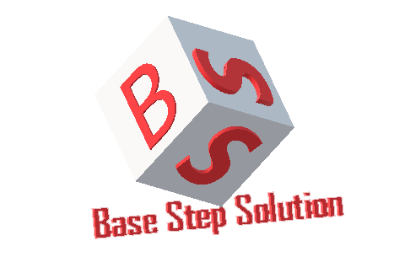

Requirement Development Process

Văn Lang Admissions

# Revision Table

|  |  |  |  |
| --- | --- | --- | --- |
| Author | Date | Reason for changes | Version |
|  |  |  |  |
|  |  |  |  |
|  |  |  |  |

Table of Contents

Revision Table 1

1. Process 3

1.1. Process Purpose 3

1.2. Process Activities/Steps 3

1.3. Activities Description 5

2. Role and Responsibility 5

3. Tools and Methods 7

4. Goal, Question, Metric: 7

4.1. Goal 7

4.2. Question 7

4.3. Metric 8

# Process

## Process Purpose

.

## Process Activities/Steps

## Activities Description

|  |  |  |  |  |
| --- | --- | --- | --- | --- |
| **Phase** | **Objective** | **Input** | **Output** | **Activities** |
|  |  |  |  |  |
|  |  |  |  |  |
|  |  |  |  |  |
|  |  |  |  |  |

# Role and Responsibility

|  |  |  |
| --- | --- | --- |
| **Role** | **Responsibility** | **Assign to** |
|  |  |  |
|  |  |  |
|  |  |  |
|  |  |  |
|  |  |  |

# Tools and Methods

|  |  |  |
| --- | --- | --- |
| **Phase** | **Method used** | **Supported tool** |
|  |  |  |
|  |  |  |
|  |  |  |
|  |  |  |

# Goal, Question, Metric:

## Goal

## Question

## Metric

|  |  |  |  |
| --- | --- | --- | --- |
| **Attribute** | **Formula** | **Purpose** | **Reference value** |
|  |  |  |  |
|  |  |  |  |
|  |  |  |  |
|  |  |  |  |